KARNATAK UNIVERSITY, DHARWAD

INTERNAL QUALITY ASSURANCE CELL (IQAC)

A Brief Report of the Webinar

A webinar on “NAAC Assessment and Accreditation Process” was organized by the Internal Quality Assurance Cell of Karnatak University Dharwad in association with the NAAC, Bengaluru on 13-8-2020, 10.30 a.m. onwards. The webinar was held on Google meet platform. The number of participants was around 120 across teachers, principals and Co-ordinators of IQAC. The event was also broadcasted live on social media for larger benefit.

The programme started as per schedule and the Vice Chancellor, Prof. Shivappa delivered the inaugural address emphasizing the need to create and sustain quality standards in the higher education institutions. Reiterating the emergency created by the COVID-19 pandemic, he urged all the stake holders of higher education, especially the teachers, to utilize this as an opportunity to learn new skills, introduce new courses and develop new process that increase the relevance of the teaching programmes.

In the first session, Dr. Shyamasundar, Adviser, NAAC laid out the need to sustain and improve quality standards. He presented an overview of the National Education Policy (2020) and mentioned that it contained numerous good aspects for improving the teaching-learning standards at all levels of education. He underscored the role of NAAC in creating quality standards and assessing the higher educational institutions and providing them an opportunity for lateral expansion and vertical growth.

In the second session, Dr. Pratibha Singh, Deputy Adviser, made a detailed presentation on “Introduction to A&A of NAAC, Registration Process and Submission of IIQA”. It was a comprehensive presentation and was quite helpful for the institutions that are gearing up for reaccreditation.

The third session on “SSR submission & DVV Process” was discussed by Dr. Vishnu Mahesh, Assistant Adviser. Many processes were explained and some of the doubts that the attendees had in their minds, regarding SSR preparation were effectively clarified.

The last presentation was on “Student Satisfaction Survey, Logistics & Peer Team Visit & AOD” by Dr. D. K. Kamble, Assistant Adviser. Every minute aspect of the methodology of conducting the student satisfaction survey and the procedures to be followed during the peer team visit were discussed. The assessment outcome pattern was also clarified.

The event which began sharp at 10.30 a.m. went up to 1.15 p.m. with last 15 minutes devoted to questions by the participants and answers by the resource persons. The meeting ended with vote of thanks by Prof. S.T. Bagalkoti, Director, IQAC. A feedback link was shared among the attendees and the brief analysis of the same is given below.

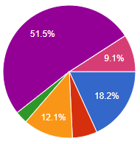  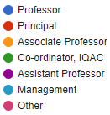 | Distribution by Designation: Apart from 81% of teachers, Principals comprised of 6%; IQAC Co-ordinators comprised of 3% and others including students and the management comprised 9.1% of the attendees.
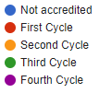  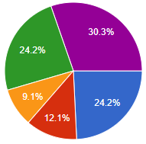 | Distribution by Level of Accreditation: That nearly 36% of the attendees were from the institutions that are either not accredited or in the first cycle of accreditation makes the event more meaningful as it helped in clearing various doubts that the people had.
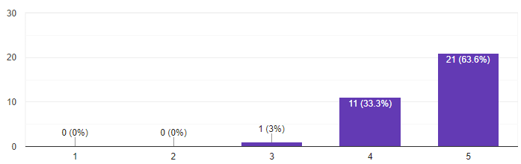 | Majority of the participants expressed that the event was quite helpful for them. Thus, while nearly 64% reported that it was highly useful, 33% reported that it was useful. Thus, the event has served its purpose of effectively disseminating the information about NAAC procedures and processes.
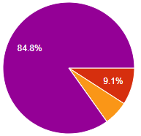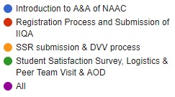 | An overwhelming majority of the participants (85%) reported that all the sessions were highly useful in preparing for their institution’s accreditation process.  Further, 97% of the attendees expected their desire to participate in more intensive events in the future.
Few Pitfalls indicated by the participants are:  - Technical problems like visibility of PPT presentations  - Technical difficulty  - Posts not visible  - Connectivity issues | Some of the suggestions made by the participants are:  - Current Educational scenario  - Students Skill Development.  - Challenges and Opportunities of NEP in India.  - Demo of online data entry with example  - Brainstorming with all the faculty members.  - Hands on training  - Conduct special webinar on each criterion Highlight about preparation of SSR

